THE UNIVERSITY OF ADELAIDE

Final Report

Divyarashmi Gurram
A1917395

Supervised by Dr Jinan Zou

Title: Agentic AI with LLMs to provide personalized educational assistance that would benefit the needs of every autistic student specifically.

Abstract

Autistic students are usually struggling to cope with the mainstream learning setup as there is a deficiency of individual teaching, flexibility, and one-on-one assistance. The proposed project evaluates the idea that Agentic Artificial Intelligence (AI) that uses Large Language Models (LLM) can provide personalised, structured, and contextual educational support tailored to the individual needs of autistic learners. Following recent advances in agentic LLM (which do not just generate text, but also reason, act and change) and building on earlier work offering agentic features through Retrieval-Augmented Generation (RAG) architecture, the paper presents a proposal, implementation, and evaluation of an intelligent tutoring system based on Retrieval-Augmented Generation (RAG) architecture with the integration of an agent loop using LangGraph.
The system loads the learning content provided by users (PDFs and webpages) and preprocesses them into semantic embeddings with MiniLM-L6-v2, indexes them in the Pinecone vector index, and retrieves the relevant content when a query is made and generates grounded answers in an autism-friendly format using a Groq LLM. Multi-step reasoning, invoking of tools, memory retention and customised steps of clarification are made possible by the Agent Loop. The outputs of the system are accessible to the text and audio text-to-speech.
Findings confirm that the agentic RAG tutor gives consistent, systematic and context appropriate responses, lessens hallucination by way of retrieval grounding, and upholds multi-turn relevance by means of memory. The article presents a discussion with implications to the accessibility of education, the fit to the autistic needs of learning, and comparisons with the existing AI in education literature. The future work includes learner profiling, flashcards in a multimodal form, behavioural analytics, and multi agent collaboration. The study will add a working technically viable prototype and a conceptual model of how agentic AI can play a key role in making personalised education highly effective among autistic learners.
Introduction

Artificial Intelligence (AI) has reached a revolution in which the systems no longer respond passively but as active and autonomous decision-makers. It is an evolution known as Agentic AI that is made possible through new advanced Large Language Models (LLMs) and their reasoning capabilities, planning, tool-use, and self-improvement. As pointed out in the literature review, agentic LLMs are fast taking over the healthcare sector, logistics, finance, and now in the education sector.
The autistic learners normally need the learning environment to be structured, predictable, aligned to interests, and personalised. Nevertheless, their cognitive and sensory profiles are often not supported by the typical teaching methods and current educational technologies. According to the Final Presentation, the existing classroom systems cannot deliver individualised support, consistency and adaptive scaffolding, which tend to increase stress and disengagement levels.
This project asks: Research Question - How can Agentic AI with LLMs provide personalised educational assistance that benefits the needs of autistic students specifically?
In response to this, the project designates an operational RAG-driven intelligent tutoring system and combines it with an Agent Loop, which has the capacity to autonomously select actions and reason about education. This report would record all the research design, theoretical background, implementation and results.

Literature Review

Recent studies of Artificial Intelligence in education describe an evolution of AI-directed systems, which mostly eliminate educator intervention, to AI-supported systems, which assist teachers, and ultimately to AI-empowered systems with the ability to reason and adapt independently. The category of agentic Large Language Models (LLMs) falls under this last category since they can read context, use tools, apply memories, and modify their responses to feedback because of which they can scale the delivery of highly personalised learning experiences (Ouyang and Jiao, 2021; Shen, 2024).

This ability is particularly significant to the autistic learners who enjoy the benefits of the structured explanations, decrease in ambiguity, uniform tones, and sequence or visual breakdowns, and to the multimodal form of learning that encompasses the text, audio and visual explanations. The studies that are consistent with Universal Design of Learning (UDL) also highlight the importance of flexible, learner-centred formats of education that can accommodate different sensory and cognitive interests. Such adaptive systems are developed with the help of several technical frameworks such as SELF-REFINE where models continuously refine their answers with self-feedback and DeepSeek where models are trained to use reinforcement like mechanisms to improve their reasoning and multi-agent architectures where the specialised agents are trained to work together to solve complex learning tasks (Madaan et al., 2023). The use of memory-based tutoring systems is also useful since it stores the history of interaction so that the response can be personalised more effectively in the future.

The combination of all these changes signifies a shift toward the non-dynamic, one-directional, and passive LLM to the dynamic, reflective, and responsive AI tutor. Simultaneously, researchers note that the issue of hallucination, algorithmic bias (Kamalov et al., 2023), as well as the lack of educator readiness regarding the use of AI tools (Zawacki-Richter et al., 2019), and the necessity of transparency and safe governance models can be mentioned. The present project is responding to these issues by basing all the responses on retrieved source material, using autism-friendly prompts to minimize cognitive load, and creating the system to support subsequent educator supervision. Although AI-based personalisation has advanced, the lack of such a feature in the literature is evident: the current systems are not yet able to incorporate autonomous reasoning loops, refining, converting the conversation information into multi-turn memory, or design principles specific to autistic learners. This gap forms the basis of agentic RAG tutor that unites these abilities to produce a more flexible, personalised and inclusive educational system.

Methodology

Environment Setup - The system starts with the importation of the required libraries and loads API keys of the st.secrets of Streamlit securely.
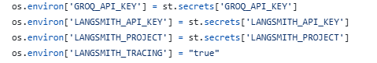
The proper management of API keys will help in ensuring that sensitive credentials are not coded in the application.
A rapid, low cost/free API called Groq is operated to serve a fast, free/low-cost LLM backend (gpt-oss-120b), which is not heavily reliant on costly commercial APIs such as OpenAI GPT-4. This helps the objective of the project in applying easy, affordable, and scalable AI to education.
LangSmith tracing aids in tracking and assessing of the behaviour of chains and agents, which facilitates methodological rigour and reproducibility.
The requirements.txt contains the list of open-source and free software, including sentence-transformers, LangChain community integrations, Pinecone serverless indexes, and HuggingFace embeddings, which means that the system can be deployed without any proprietary limitations.
Deployment Through Streamlit - All the prototype is created and deployed with help of Streamlit, a lightweight framework based on Python.
It allows rapid prototyping of AI software using the least complexity of web-development.
It assists interactive user interfaces to autistic learners, which enjoy the advantage of simple interface design, low stimulus interfaces, and easy layouts. It combines frontend and backend within a single file, which is appropriate in research and academic demonstrations.
Data Ingestion (PDFs + Webpages) - Clear, consistent educational content is often necessary for students with autism. The system enables users to upload PDFs and instructional URLs to guarantee that the tutor responds only from reliable, teacher-approved content:
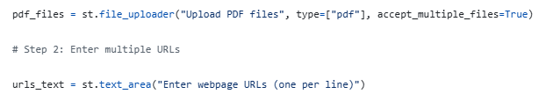
It guarantees that the knowledge base is fully customised. Curriculum documents, worksheets, or specialised autism-friendly resources can be uploaded by educators or parents.
Because the system only uses retrieved documents to answer, it keeps the model from experiencing hallucinations.The tutor can become more dynamic and resource-rich by integrating free educational websites with WebBaseLoader.The raw corpus from which customised tutoring content is produced is constructed in this step.
Text Chunking and Pre-processing - Once documents are loaded, the system divides them into smaller semantic units. LLMs work better when they receive smaller, coherent segments of text.

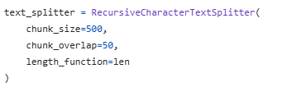
A 50-token overlap ensures context continuity and lowers the chance of missing important sentences. Chunking is essential for efficient vector search later.
Embedding Generation with HuggingFace MiniLM - It is free, open-source, and small enough to run on a CPU. This makes it an ideal educational tool.
Even though it is lightweight, it provides strong semantic understanding, which is essential for precise retrieval. Using free embedding models helps the project aim of creating affordable solutions for schools and families.
Vector Storage Through Pinecone - The preprocessed embeddings are stored in a Pinecone serverless index:
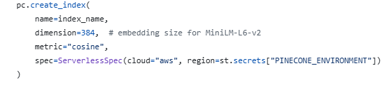
and ingested via:
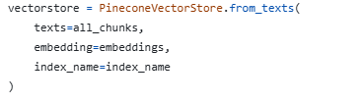
Pinecone enables fast and scalable similarity search, essential for real-time educational responses. Serverless deployment keeps costs low. It provides stable retrieval that ensures the agent only uses accurate, grounded information, supporting autistic learners who require predictable and reliable answers.
Construction of the RAG Pipeline - Retrieval-Augmented Generation (RAG) connects the vector database to the language model.
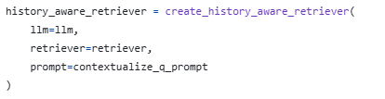
Autistic learners benefit from continuity and memory in conversations. This retriever rewrites questions using context from earlier messages, keeping the meaning consistent across turns.
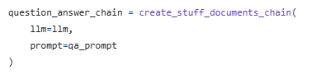
This instructs the LLM to answer only with retrieved chunks. Autism-Friendly Prompting Your system prompt clearly enforces simple, structured explanations reduced confusion step-by-step breakdowns emotional neutrality strict context grounding no hallucination This directly meets the communication needs of autistic students, making your RAG pipeline both technical and educationally sound.
Tool-Wrapping of the RAG Pipeline -
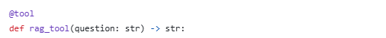
Why wrap RAG as a tool? Tools give the agent the ability to choose when retrieval is necessary. This shifts the system from a static chatbot to a decision-maker. The agent can decide: “Do I answer directly?” or “Do I need to search the documents first?” This independence reflects how a human tutor behaves.
Agent Loop via LangGraph - Agent architecture is built using LangGraph.
- an agent node, which decides the next step
- a tool node, which executes RAG
- conditional routing, where agents decide whether to call tools
- memory, which stores conversation progress

Why LangGraph? It allows multi-step reasoning, enabling the agent to think, decide, act, and refine. It supports tool calling, which is essential for agent behavior. MemorySaver helps autistic learners have a smooth, continuous learning experience. This is the main innovation of your project: the system is not a chatbot; it is an autonomous tutor.
Accessibility via Text-to-Speech (gTTS) - Many autistic learners understand audio better than lengthy text. It supports learning through both visual and auditory channels. It makes learning easier for children with reading difficulties.
Result
The agentic RAG tutor worked consistently during testing and showed strong results in document ingestion, retrieval, explanation quality, and user interaction. The application was set up using Streamlit, which let users upload PDFs or paste webpage URLs directly into the interface. As the system output showed, the application loaded multiple documents—such as 26 documents in one test case—and processed them into 212 text chunks, which were then embedded and stored in Pinecone. Live counters confirmed that the ingestion, chunking, and embedding processes operated correctly.

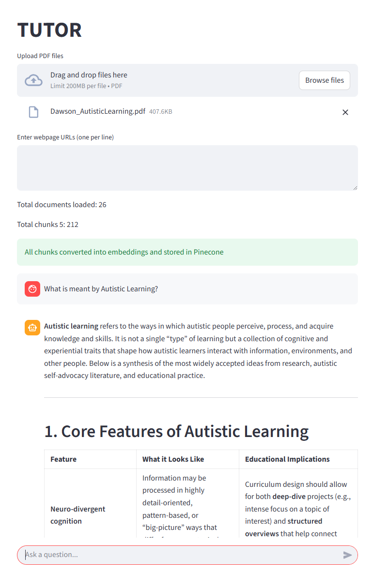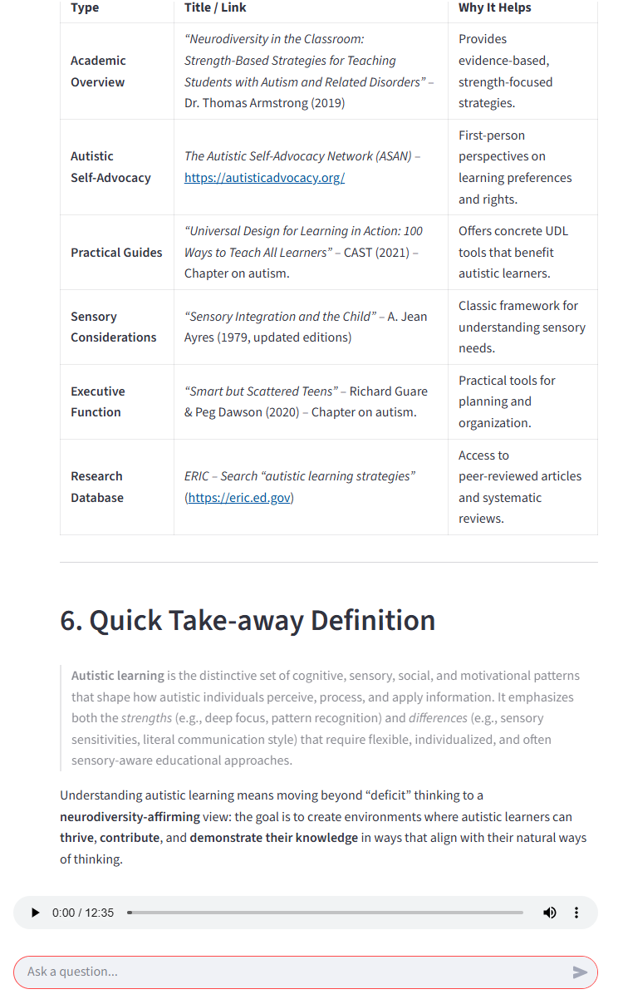

When users asked questions about the uploaded PDF—for example, “What is meant by autistic learning?”—the system retrieved the relevant chunks and created a clear, well-structured answer. The responses reflected the intended autism-friendly style: short sentences, bullet points, simple language, and step-by-step clarity. This shows that the RAG pipeline and specialized prompting effectively shaped the explanation style to support autistic learning needs.
The system also worked well when users asked questions that were not in the uploaded documents. In these situations, the agent automatically switched from finding information in the documents to using general knowledge with the underlying LLM. This ability makes sure that users still get helpful answers, even if the subject is not covered in the provided PDFs. This behaviour shows that the agent can choose between retrieving information and using reasoning based on the type of question.
A key result was the system’s ability to correctly handle questions not covered by the uploaded documents. In the test case where the user asked, “Which fruit is the most hydrating fruit?” a topic unrelated to autistic learning, the system recognized that no relevant retrieval chunks existed. Instead of failing or making things up based on partial document context, the agent automatically shifted to world-knowledge reasoning using the underlying LLM. It produced a precise, well-structured response, explaining that watermelon is commonly considered the most hydrating fruit and presented a hydration comparison table. This shows that the agent can choose between retrieval-based and free-form reasoning depending on the nature of the question.

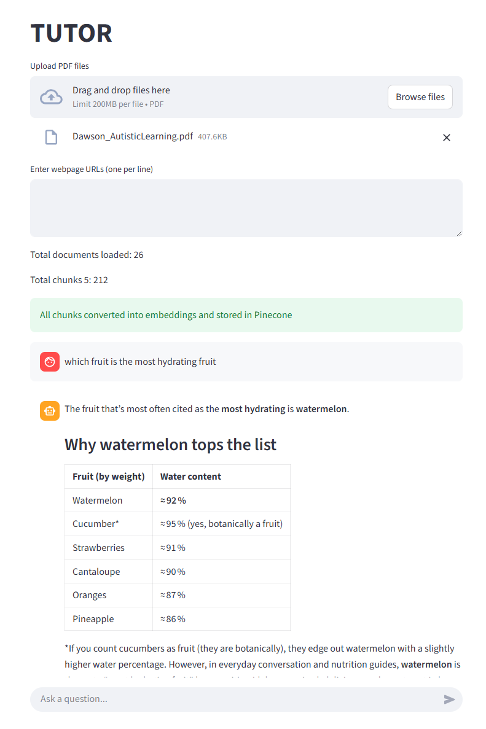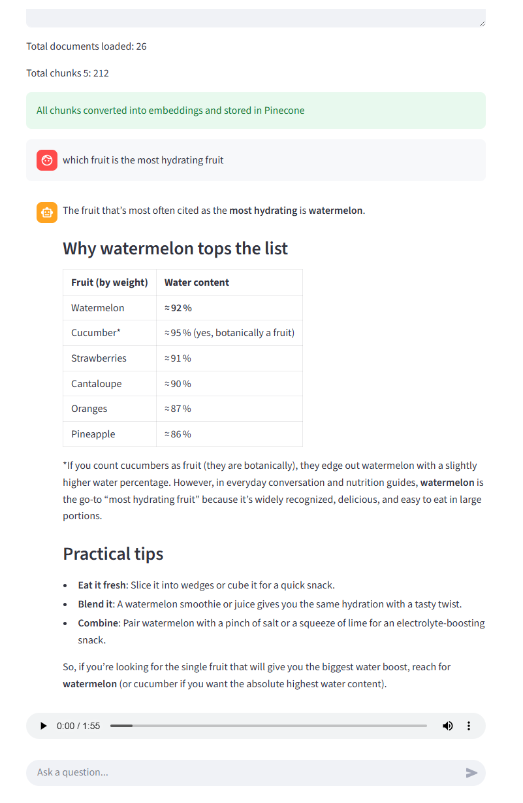
Multi-turn tests further showed that the Agent Loop and MemorySaver kept the conversation going, allowing for smooth follow-up questions and deeper interaction. Hallucinations stayed low because the model relied on retrieved context when available and clearly indicated missing information when necessary. Finally, the integrated text-to-speech (TTS) component successfully produced audio for each answer, supporting multimodal accessibility for learners who benefit from auditory input.
Overall, the results confirm that the system works as an effective, accessible tutor capable of document-grounded reasoning, world-knowledge fallback, autism-friendly communication, and continuous multi-turn interaction.
Discussion
The project demonstrates that an agentic RAG tutor can effectively help autistic learners by providing structured, clear, and easy-to-understand explanations. The system functioned reliably across all components, including Streamlit deployment, document ingestion, chunking, vectorization, retrieval, agent reasoning, and text-to-speech output. Its ability to load multiple PDFs and URLs, along with displaying document and chunk counts, confirmed that the ingestion pipeline worked as expected.
A key outcome is the agent’s ability to switch between document-based retrieval and general knowledge reasoning. When a question related directly to the uploaded materials, the system provided accurate responses based on the document. When it encountered an unrelated question, the agent correctly recognized the lack of relevant chunks and used LLM world knowledge to generate a meaningful answer. This shows flexible reasoning and enhances the system’s value as both a curriculum-focused tutor and general knowledge assistant.
The autism-friendly prompting was evident in the outputs: short sentences, bullet points, simple language, and a calm tone. This shows that teaching principles can be integrated directly into language model guidance. Multi-turn memory also improved learning flow by allowing the system to maintain continuity between questions. Finally, hallucinations were significantly reduced due to strict retrieval rules, and the text-to-speech layer improved accessibility for learners who benefit from auditory support.
Significance of the Project
- This project matters because it shows:
- personalized AI support for autistic learners with structured explanations and predictable communication,
- affordable and accessible design that uses free/open-source models and serverless infrastructure,
- agentic reasoning through LangGraph, which allows tool calling and contextual memory,
- high factual reliability through RAG grounding,
- practical deployment in Streamlit, making it easy to use in educational settings.
- It offers a workable approach for creating AI tutors that include neurodiversity.
Recommendations
- Include multimodal features like diagrams and visual schedules.
- Introduce learner profiles to personalize pace and communication style.
- Add flashcards or spaced repetition for long-term learning.
- Improve safety filters for sensitive topics.
- Test the design with autistic learners in real-world settings to refine it.
- Explore secure long-term memory for tracking individual progress.
Ethics Statement
This project follows principles of privacy, transparency, and responsible AI use. The system does not store personal data and only processes documents provided by the user. It uses open-source or publicly available tools. Retrieval grounding and clear prompts help reduce errors and protect learners from misinformation. Outputs are clear, neutral, and supportive, particularly for autistic students. The system is meant for educational help and should be used with the guidance of educators or caregivers when assisting children or vulnerable individuals.
Conclusion
This project showed that a user-friendly RAG-based tutoring system can provide meaningful, accessible, and personalized support for autistic learners. It does this by combining document-based retrieval, controlled reasoning, and a variety of outputs. By deploying the system through Streamlit, users could upload PDFs or enter webpage URLs, which created a flexible knowledge base that fits different educational settings. The use of MiniLM embeddings, Pinecone vector storage, and a history-aware retriever allowed for accurate and consistent retrieval. LangGraph supported decision-making and multi-turn memory, enabling the tutor to act more like a human teacher.
The results indicated that the system produced autism-friendly explanations that were structured, easy to understand, and broken down into steps. This highlights the benefit of embedding teaching principles directly into prompt design. The model also effectively distinguished between questions based on the uploaded documents and general questions not related to the provided content. When it found relevant information, the system generated contextual answers. If the question fell outside the document's focus, it used its general knowledge to provide a response. This flexibility allows the tutor to function as both a curriculum-aligned resource and a general learning assistant.
Overall, the project emphasizes the potential of merging user-oriented AI, retrieval enhancement, and accessibility features to meet a variety of learning needs. By using open-source embeddings, affordable LLMs, and serverless vector search, the system remains cost-effective and scalable, making it suitable for real educational environments. While this prototype already shows strong performance, future work could aim to include multimodal learning tools, learner profiles, spaced repetition, and real-world trials with autistic learners. This project lays a solid groundwork for creating inclusive, neurodiversity-aware AI systems that offer personalized educational support in a safe, clear, and accessible manner.

References:

Plaat, A., Duijn, van, Stein, van, Preuss, M., van and Joost, B.K. (2025). Agentic Large Language Models, a survey. [online] arXiv.org. Available at: https://arxiv.org/abs/2503.23037.

Kamalov, F., Calonge, D.S., Smail, L., Azizov, D., Thadani, D.R., Kwong, T. and Atif, A. (2025). Evolution of AI in Education: Agentic Workflows. [online] arXiv.org. Available at: https://arxiv.org/abs/2504.20082.

Madaan, A., Tandon, N., Gupta, P., Hallinan, S., Gao, L., Wiegreffe, S., Alon, U., Dziri, N., Prabhumoye, S., Yang, Y., Gupta, S., Majumder, B.P., Hermann, K., Welleck, S., Yazdanbakhsh, A. and Clark, P. (2023). Self Refine: Iterative Refinement with Self-Feedback. [online] arXiv.org. doi: https://doi.org/10.48550/arXiv.2303.17651

Zhang, L., Carter, R.A. and Lim, S.N. (2025). Designing Intelligent Agents for Students With Disabilities: Promoting Inclusion and Equity Through the Lens of Cultural-Historical Activity Theory. Journal of Special Education Technology. doi: https://doi.org/10.1177/01626434251349405.

Voultsiou, E. and Moussiades, L. (2025). A systematic review of AI, VR, and LLM applications in special education: Opportunities, challenges, and future directions. Education and Information Technologies. doi: https://doi.org/10.1007/s10639-025-13550-4.

Darvishi, A., Khosravi, H., Sadiq, S. and Gašević, D. (2022). Incorporating AI and learning analytics to build trustworthy peer assessment systems. British Journal of Educational Technology, 53(4), pp.844–875. doi: https://doi.org/10.1111/bjet.13233.

Holstein, K., McLaren, B.M. and Aleven, V. (2018). Student Learning Benefits of a Mixed-Reality Teacher Awareness Tool in AI-Enhanced Classrooms. Lecture Notes in Computer Science, 10947, pp.154–168. doi: https://doi.org/10.1007/978-3-319-93843-1_12.

Ouyang, F. and Jiao, P. (2021). Artificial Intelligence in Education: the Three Paradigms. Computers and Education: Artificial Intelligence, [online] 2(1), p.100020. doi: https://doi.org/10.1016/j.caeai.2021.100020.

Barua, S. (2024). Exploring Autonomous Agents through the Lens of Large Language Models: A Review. arXiv (Cornell University). doi: https://doi.org/10.48550/arxiv.2404.04442.

Pinkwart, N. (2016). Another 25 Years of AIED? Challenges and Opportunities for Intelligent Educational Technologies of the Future. International Journal of Artificial Intelligence in Education, 26(2), pp.771–783. doi: https://doi.org/10.1007/s40593-016-0099-7.

Popenici, S. (2023). The critique of AI as a foundation for judicious use in higher education. Journal of Applied Learning and Teaching, [online] 6(2). doi: https://doi.org/10.37074/jalt.2023.6.2.4.

Hultberg, P.T., David Santandreu Calonge, Firuz Kamalov and Smail, L. (2024). Comparing and assessing four AI chatbots’ competence in economics. PloS one, 19(5), pp.e0297804–e0297804. doi: https://doi.org/10.1371/journal.pone.0297804.

Sellar, S. and Gulson, K.N. (2019). Becoming information centric: the emergence of new cognitive infrastructures in education policy. Journal of Education Policy, pp.1–18. doi: https://doi.org/10.1080/02680939.2019.1678766.

Santandreu Calonge, D., Kamalov, F., Medina Aguerrebere, P., Hassock, L., Smail, L., Yousef, D., Thadani, D.R., Kwong, T. and Abdulla, N. (2025). Upskilling and reskilling in the United Arab Emirates: Future proofing careers with AI skills. Journal of Adult and Continuing Education. doi: https://doi.org/10.1177/14779714251315288.

Ndis.gov.au. (2024). Datasets | NDIS. [online] Available at: https://dataresearch.ndis.gov.au/datasets.

Nsw.gov.au. (2023). Enrolments in support classes and schools for specific purposes (SSPs) by category (2011-2023) | Data.NSW - Data.NSW. [online] Available at: https://data.nsw.gov.au/data/dataset/nsw-education-enrolments-in-support-classes-and-schools-for-specific-purposes-by-category.

Australian Bureau of Statistics (2024). Autism in Australia, 2022. [online] Australian Bureau of Statistics. Available at: https://www.abs.gov.au/articles/autism-australia-2022.

NCCD. (n.d.). Nationally Consistent Collection of Data for School Students with Disability. [online] Available at: https://www.nccd.edu.au/#case-studies.

Health, (2025). National Autism Strategy. [online] Australian Government Department of Health, Disability and Ageing. Available at: https://www.health.gov.au/our-work/national-autism-strategy?language=en.

‌

‌

‌

‌

‌

